INCLUSION OF POLITICAL PARTIES IN THE RTI ACT FOR A MORE DEMOCRATIC DEMOCRACY:
Intersection of Article 19 and Public Authority under Section 2(h) of the RTI Act
Dikshi Arora & Shivank Kumar

RESEARCH QUESTION: WHETHER POLITICAL PARTIES FALL UNDER SECTION 2(h) OF THE RTI ACT AND QUALIFY AS "PUBLIC AUTHORITY" OR NOT?

ABSTRACT-

Under section 29A of the Representation of the People Act 1951, political parties are given a statutory status. They are the key instrumentalist of the democratic governance. Under the tenth schedule of the Constitution of India, parties are given the power to disqualify the legislators from parliament and the state assemblies. The elected representatives enjoy legislative as well as executive authority. These wide ranging powers and functions of the parties are clearly the indicative of their public character. The question of whether the political parties should come under the ambit of the Right to Information Act, 2005 is a matter of fierce debate and a long- standing issue. Election commission and the law commission have recommended the inclusion of parties under the ambit of RTI to keep a check on their funding, its sources and measures to promote transparency and accountability in their activities. This research paper aims to critically analyze the nature of their activities performed by the parties, the heart of the debate is whether they fall under Section 2(h) of the Right to Information Act and qualify as “public authority” along with this, the paper discusses right to information under Article 19 and 21. The study is conducted through referring provision of the Indian Constitution, related legislations and number of precedents.

Keywords: RTI, Article 19, Political Parties, Public Authority, Public Character

TABLE OF CONTENT

S.No. | INDEX | Page No.
1 | Introduction | 5-7
2 | Political Party: An important Stakeholder in Democracy | 7-8
3 | Income and its Sources | 8-11
4 | Global Aspect of Political Funding and Public Financing | 12-14
5 | CIC Decision in 2013: A Timeline  - The Chief Information Commissioner’s order- Anil Bairwal v. Parliament of India | 14-15
6 | Analysis of Section 2(h)  Body owned or controlled by an appropriate government  - The government funds political parties in the form of VIP houses, bungalows, offices, and suites, etc  - Government allots plots of land to political parties which have an exorbitant value  - The government funds political parties by providing them free airtime on Doordarshan during election campaign worth crores of rupees  - The government funds political parties by providing them free airtime on AIR during elections  - Government funding in the form of providing electoral rolls  - Government funding in the form of heavy tax exemption to the political parties under Section 13 A of Income Tax Act | 16-23
7 | Arguments from both Sides | 23-24
8 | Public Character | 24-25
9 | What’s Next? | 25-26

INTRODUCTION

As rightly said by Jeremy Bentham, an English philosopher – “Without publicity, no good is permanent; under the auspices of publicity, no evil can continue.”

With a population of over 1.3 billion, India stands as the world’s largest democracy and people play a key role in making or breaking the government. The citizens are the most important element of a country’s democracy and termed as the “masters of any democracy”. No denying the fact that the Right to Information Act, 2005 is an asset to India’s democracy. If a man is updated or aware then only he can think in the right manner and proceed accordingly.

“Right to Information Act in India is the top 5 laws in the world. Use it.”
- Shailesh Gandhi, RTI Activist

The Indian Parliament has passed the Right to Information Act on 15th May 2005 after being proposed in front of the Lok Sabha in December 2004 during the tenure of the UPA government which was led by then Prime Minister Dr. Manmohan Singh. The main objective behind the passing of the act was “to contain corruption and to hold Governments and their instrumentalities accountable to the governed”.RTI act empowers citizens, keep a check on corruption and deviation to make democracy work in an ideal sense by ensuring efficient government functioning.The country’s growth rate and administrative quality significantly depend upon the efficiency of the ruling government. An empowered and informed or aware person is in a better state of vigilant and he facilitates the required transparency in working of the government machinery.

India was ranked at 68 out of 144 nations in the global competitiveness report 2019 which is released by the World Economic Forum (WEF) and examines the nation on the criteria of efficiency of the government or administration. This report must be given due consideration while studying the Right to Information Act.

In India, the number of people filing RTI applications to seek information is more than 4,000 per dayand from the day of its enactment till 2015 i.e., in 10 years over 1.75 crores of RTI applications were filed. The numbers are huge. Popular NGO, Mazdoor Kisan Shakti Sangathan and leaders like Aruna Roy and many other grass-root organizations played a vital role in creating awareness amongst the people about having the right to access information of public concern.
The Right to information is not only a fundamental right but also the legal right of every citizen of India. It comes under Article 19 of the Indian constitution which talks about the Right to freedom of speech and expression. It is so because a person can only speak or express himself only if he is aware and has information about the concerned subject. RTI codifies a fundamental right of the citizens of India.In, State of Uttar Pradesh vs. Raj Narain & Ors, it was observed that from the concept of Freedom of speech and expression, the concept of the right to know is derived. In, R.P Limited v. Indian Express Newspapers, it was observed by the apex court that in a participatory democracy, the Right to know is one of the important ingredients. The court formed this opinion by going through Article 21 of the Indian Constitution.The certain laws and Acts restrict the ambit of the RTI act, such as the Whistle Blower Act, 2011 and Official Secrets Act, 1923. Current act allows the citizens to demand information from the public authorities which concerns various aspects such as their structure and functioning. There have been three-tier systems made which ensures a systematic approach towards the enforcement of RTI Act. The Department of Personnel and Training, Ministry of Personnel, Public Grievances and Pensions has taken the initiative of the launching of the RTI Portal. The portal has details of all the PIOs or the first appellate authorities and searches for RTI information, which is published on the internet under various public authorities of central and state governments. Through the amendment of 2019, few changes have been made in the act. It was heavily criticized on the ground that the act challenges the independence of the Information commissions and it also subverts the democratic institution or setup at large.
The inclusion of the political parties under the ambit of the Right to Information, Act has been a matter of heated debate and discussion for a long time. Many RTI activists are continuously demanding their inclusion under the ambit of the act so that there could be a check over there heavy income and expenditure. Prominent national political parties such as the BJP, INC, BSP, NCP have shown their disagreement on this and since they don’t consider themselves as a public authority as they are not substantially financed by the Indian government. Many parties submit that the details of their income and expenditure are already in the public domain. The Election commissioner in its order dated May 2018 stated that political parties don’t come under the purview of the RTI Act but later clarified that they qualify as the “Public Authorities” under Section 2(h) of the Act.

POLITICAL PARTY: AN IMPORTANT STAKEHOLDER IN DEMOCRACY

India is the world’s biggest democracy. Every person has the power to choose their representative who represents them in the Legislative Assemblies, Parliament, and Local bodies. It is no doubt that in a country like India, the face of a candidate’s face is important when it comes to individual capacities and personal merits. But keeping the fact that there are so many religions and castes prevalent in India and large strata of people in the country still votes by keeping the caste or religion in mind, there come the major players of this electoral fest i.e. the political parties. Generally, the party symbol is kept in mind while voting and there are some traditional or fixed voters for particular parties called their vote banks. Therefore, in a democracy, it is the party organization that carries more weight than the candidate in their personal capacity. Hence, in any political system, the political party is considered as an important agency for all the political and social system.

Attainment of political power is strived by the parties. They play a crucial role in the linking of all political forces in society with the state. An organized expression is given by them to the interests and is made politically effective. Roles played by the political parties are as follows:-

1- They access the country’s problem and suggest the required solutions for the same.
2- They stimulate the people for active participation in political socialization and make them aware of the problems, a country is going through.
3- They make efforts towards mobilization of the masses to make them take participation in decision making and party programs.
4- To do a criticism of policies and programs of other political parties after evaluating them.
5- Political parties, while in opposition, play a crucial role in any democratic setup in the form of questioning the ruling party on a particular issue or a particular bill/policy. This is required for the healthy functioning of any government by making them questionable to the people.
India has a large number of political parties registered with the election commission. According to the figures, there is a total of 2599 parties registered with the commission, out of which 8 are national, 53 are state and rest are categorized as unrecognized parties. Political parties act as the agencies which are responsible to the citizens and gather various societal viewpoints and put them in front of the government.

INCOME AND THEIR SOURCES

In India, the common man is accountable for every penny which he earns. But it is said that hefty funding to political parties in the nation has gone unregistered despite having announced a mammoth total income of more than Rs 9000 crores in 10 years i.e., from 2005 – 2015. Amongst all the parties, the national political parties alone have around 4400 crores of funds received from donations and other voluntary contributions which form 49 percent of funds received by all political parties of the country.

It can be seen that in many of the world’s democracies, there are provisions for this and are already in practice in nations such as the Philippines, the United States of America, Australia, Germany, Japan, and the United Kingdom, etc. In order to survive and grow, they need funds and most of the funding which they get comes from the individual donation, corporate donations, and the electoral trusts. Alone these modes generate two-third of the total political funding. In the year 2017-18, corporate donations resulted in 92 percent of BJP’s total funding. With the introduction of electoral bonds, these types of political funding are likely to be increased in the coming year.

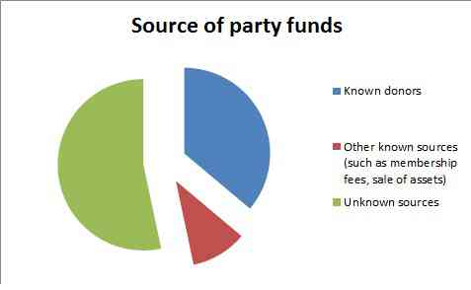

It can be seen from the available data that in India, donations from unknown sources dominate the political funding. The donation of less than worth Rs 20,000 is permitted to remain hidden. Half of the total donations come from the sources which are unknown. In the year 2017, the NDA government introduced electoral bonds which made it even easier for the political parties to collect funds from anonymous sources. In order to get a 100 percent tax exemption, it becomes important for the political parties to submit the details of all the donations received of more than Rs 20,000 under section 29C of the Representation of People Act, 1951. It is mentioned in section 29C of the act that-

- The treasurer of the parties or any person authorized by them should prepare a report in each financial year on the behalf of parties which must include namely: - the details of every contribution received by them of more than Rs 20,000 from any individual person.
- The details of every contribution which is more than Rs 20,000 given by companies other than the government companies in each financial year.

According to an ADR report, for all the national political parties, excluding the CPI (M), Rs 689 crore was funded to them from unknown sources, this resulted in 53 percent of the total funding. 36 percent comes from the known sources which amount to 467 crores of their total income, rest 11 percent comes from sources like membership fee or sale of assets, etc.The election watchdog also analyzed the party-wise income in which the BJP got 93 percent of the total known donation with Rs 437 crore in the year 2017-18 whereas the congress came distantly second with only 5 percent i.e. a mere Rs 26 crore of the total known donations.
It is no wrong in saying that things got worsened after coming of electoral bonds which were introduced with the finance bill. In the year 2017-18, the BJP topped the table by garnering 95 percent of the total value of the electoral bonds bought during that year. Navin Chawla, the former chief election commissioner, stated that the electoral bonds will give rise to the circulation of black money in politics and also stated that the bond scheme has emerged as the “greater method of camouflage”.

Foreign funding to the political parties is prohibited under the Foreign Contribution Regulation Act, 1976 which restricts the parties from accepting a donation from the foreign companies and the companies in India which are owned by foreign firms. According to the Association for Democratic Reform’s report, the BJP and INC have violated the FCRA law and accepted foreign funding between the fiscal year 2003-04 and 2011-12. A total of Rs 29 crore was accepted by both parties. In the year 2014, the High Court of Delhi gave an important judgment in which both the parties were held guilty for violation of FCRA norms that pertained to violation until the year 2010. The finance bill of 2018 amended the finance bill of 2016 which made amendments to FCRA and further pushed the threshold to the year 1976 which was previously 2010. Therefore, the retrospective effect on the bill was given by almost 35 years nullifying the liability of the offenders.
The corporate funds heavily to the political parties and are key donors to the parties. They do this in the hope of getting favor from the parties when they come in power. Donations are given to them either directly or by the formation of electoral trusts. Introduced in the year 2013 by the UPA government, electoral trusts created a layer of opacity on the corporate funding to the political parties. The trusts formed to receive contributions from various corporate and distribute the funding received by them to various parties making the common people unaware that which company is holding back of which party. From the stats available, it can be seen that in the fiscal year 2017-18, out of the total funding received from 22 registered electoral trusts, 86 percent went to the ruling party i.e., BJP. Therefore, it is not surprising to see the stats which mention that BJP got the donations nine times more than that of the other five national parties combined.

GLOBAL ASPECT OF POLITICAL FUNDING AND PUBLIC FINANCING

Many countries have taken steps to curb electoral malpractices and maintain transparency in political funding. Steps such as direct funding to the parties and allowing public subsidies lessen the dependency on ‘interested money’ and to give equal opportunity to every political party in the democratic process. European countries like Germany and the UK are providing state subsidies to reduce the dependence on “interested money”.
India’s political funding regime is under tremendous stress for many reasons, but the most significant one being the rising election expenses. In Indian elections, vote-buying is a common phenomenon, candidates leave no opportunity to make their election campaign a grand one, they spend a considerable amount of money to ensure a decent election campaign in constituencies which are sometimes as big as some European countries. A mammoth Rs 60,000 crores were spent in 17th Lok Sabha elections making it the most expensive democratic election ever.

To reduce the malpractices in electoral processes, many countries have established strict norms for financial disclosure, ban on corporate donations, having spending limits, campaign timings, institutionalize contributions, etc. The most important reform to curb the problem used by many countries is public funding of parties. However, this concept is a century old and was introduced by Latin American nations. In 1920, Uruguay was the first country in the world to introduce state subsidies which were further borrowed by Argentina and Costa Rica. Around 7 Latin American nations have this system of funding currently. Presently around 68 percent of total countries have already made norms for public funding and it seems to be the most common electoral reform. Most of the European countries have used the said process, the UK and Germany being the leading examples. The process was introduced in Germany in the year 1950 which was further implemented by France and the UK. In the 1960s, it was introduced in the USA during the tenure of President John. F. Kennedy.
In Canada, to make political parties less reliable on the corporate, the government has introduced political funding with stringent regulations including tax incentives for smaller donations. While it was unsuccessful in India when tax incentives for corporate donations were introduced but tax incentives for smaller contributions can be made to receive more contribution from smaller sources and less dependency on corporate funding.
In Germany, there is a method of matching grant which was introduced by their government. The matching of the funds raised by the parties is done through other means. This can also have a great impact on the political parties by making their reliance less on the corporate and incentivizing them to seek more donations through smaller contributions.
In the case of Sweden, where the parties once relied heavily on corporate funding for the electoral purpose, there a tremendous change can be seen in terms of political funding. After the imposition of government subventions, it had a radical effect on funding and parties voluntarily stopped taking donations from big corporate houses.
From the above reviews of various nations, routing of public subsidies in a careful manner is pertinent. If the subsidy is received by the party head office, then the control over the wealth and power would be with some handful of people at the party. It is also to be kept in mind that most of the regional parties in India are family run and are feudal in their structure. The threshold must be in a manner that it should not result in wastage of public money, rather it should encourage competition. If the subsidies are given in an orderly manner and directly to the candidates then it will make lower-level candidates strong and also it will strengthen party fraction.
Therefore, it can be said that public funding is helpful to curb election finance-related malpractice but it can’t be the only cure to the problem. It provides mixed results at its best and varies from country to country. While it is promising in many democracies but failure in some. Through strict limits, disclosures, and strong regulations, countries should minimize the dependency of political parties on corporate or private money and they should infuse white money in the process and must incentivizing various other contributory ways including tax-free loans or donations from small sources.

CIC DECISION IN 2013: A TIMELINE

The demand for inclusion of the political parties under the RTI act dates back to the year 2009 when an NGO named Association for Democratic Reforms (ADR) filed an RTI request for information of ‘ten maximum voluntary contributions’ received by them in last five years, but none of them took the application seriously. The Indian National Congress contended that they do not fall under the ambit of the act as they are not a public authority while the BJP didn’t even bother to reply to the filed application. Following this, ADR represented by RTI activist Subhash Agarwal filed a petition with the Chief Information Commissioner and the case was fought for the next three years.

In 2009, an RTI request was made by theAssociation for Democratic Reforms (ADR) to seek the amount of donations/contributions received by national political parties. It doesn’t receive a good response. Almost after one year, CPI (M), INC and NCP conveyed their denial to compile under the category of public authority on 8th November, 15th November and 27th November 2010 respectively. CPI produced information on 21st March 2011 whereas parties like BJP and BSP didn’t even reply or paid any heed to the request made by ADR. In March 2011 ADR moved to CIC to file this non-compliance. After more than one year (on 26th September 2012), the first hearing of the case was made. Six national political parties were the respondent but NCP and CPI were the only two parties who were present for the hearing. The next hearing was made in November 2012 where details of substantial funding provided to political parties were disclosed.

The Chief Information Commissioner’s order- Anil Bairwal v. Parliament of India
On 3rd June 2013, the three-member committee declared six national political parties as a public authority. While categorizing it under public authority, three final reasoning or arguments were projected,
- They are substantially financed by the government
- They are continuously involved in performing a public duty
- They have important constitutional and legal rights and liabilities to perform or undertake.

Also, they were directed to designate appellate authorities and Chief public information officers (CPIOs) at their headquarters within six weeks. CPIOs were obliged to dispense the asked information within 30 days. The parties did not pay heed to the CIC order instead there were attempts to amend the RTI Act during the monsoon session of parliament in October 2013. The amendment witnessed strong opposition from many civil societies and the issue was referred the standing committee.
None of the political parties obeyed the order of the CIC and after 17 months when the order was passed, the CIC issued a show-cause notice to the political parties. In November 2014 CIC demanded political parties to produce their general secretary in January 2015 for further action. But political parties didn’t compile the decision of CIC. There were many incidents where all the parties formed a consensus and did not appear for the hearing. ADR along with a famous RTI activist, Subhash Agrawal filed a writ in SC in July, 2015 to implement the decision given by CIC in 2013. Mr. Agrawal also played an important role in bringing the office of Chief Justice of India under the ambit/purview of the Right to Information Act. In June 2016 three-member committee was formed to by CIC to further see the matter and implement the decision. Next month itself, after hearing, one member rescued himself and the process was slow down further. New committee formed in August 2017. One member retires in September 2017 and another in January 2018. Till now no further action is taken.
ANALYSIS OF SECTION 2(h)

As per section 2(h) of the act, "public authority" means any authority or body or institution of self- government established or constituted--
(a) “By or under the Constitution;
(b) By any other law made by Parliament;
(c) By any other law made by State Legislature;
(d) By notification issued or order made by the appropriate Government, and includes any--
(i) Body owned, controlled or substantially financed;
(ii) Non-Government organization substantially financed, directly or indirectly by funds provided by the appropriate Government.”
To come to a consensus regarding the fate of Political parties under RTI, it becomes important to analyze section 2(h)(d)(i) and section 2(h)d(ii) of the Right to Information Act in brief. Any organization which passes the test of Section 2(h) under the RTI Act qualifies as a public authority. Not to forget that it is not necessary that only the government organizations are to be involved under the ambit of this act. In section 2(h)(d)(i) and section 2(h)d(ii) provisions are mentioned for the same.

Body owned or controlled by an appropriate government
As far as ownership of an organization is concerned, there must be some legal title to the organization and the government must have absolute control over the affairs of that organization. Therefore, a body/organization is a public authority if it falls under the ownership of the government under section 2(h) of the act. It can even be a public authority if it is substantially financed by the government. Many parties give the reasoning that they are not being substantially financed by the government, therefore there is no point in bringing them under the RTI Act. Let's break the myth.
It can be seen from the given data that how political parties are being funded substantially by the government:-

- The government funds political parties in the form of VIP houses, bungalows, offices, and suites, etc.
The government has given many bungalows to INC, BJP, BSP, NCP, and CPI(M) on rent at a very concessional rate at prime locations in Lutyens Delhi, where the rate of land is very high and it can be seen that total 66.53 crores has been spent on these bungalows by the government in five years which is a considerably big amount. Below is the detail of allotted accommodations and the monetary value of it.
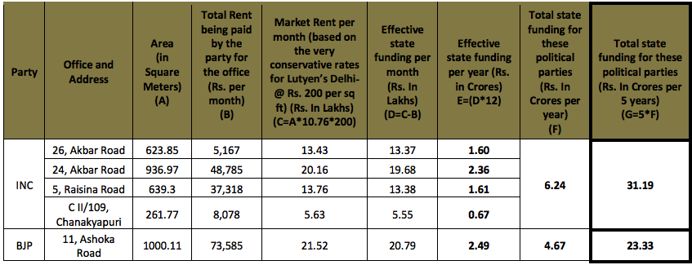
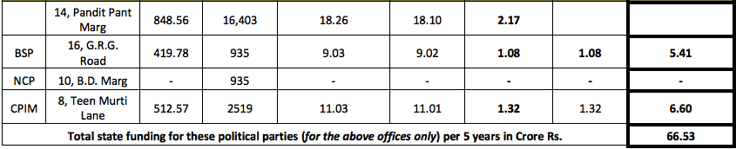

Reports generated by many real estates giants like Citigroup and Cushman and Wakefield provided some current market rates of land in Delhi. The land prices in Central Delhi where the plots, bungalows, and offices are allotted to the parties can be assessed by looking upon the given data of recent property deals-
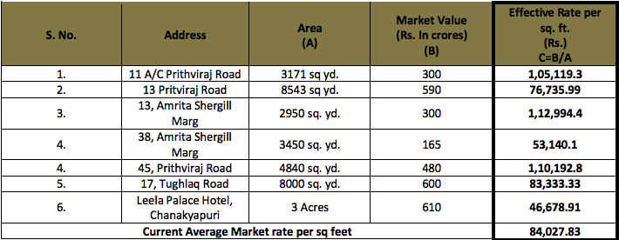

- Government allots plots of land to political parties which have an exorbitant value.
Taking Rs. 60,000 as the rate of per square ft. in Lutyens Delhi as stated by many real estate companies the below data is generated. We can see from the given data that some of the properties are rated more than Rs. 500 crores and many are rated above Rs. 100 crore and every plot are greater than Rs. 50 crore.
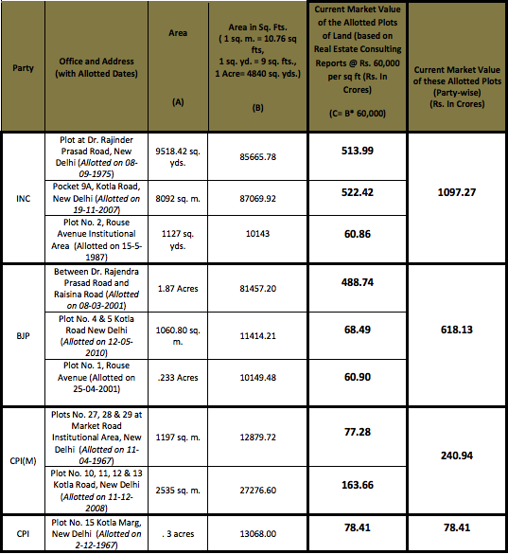

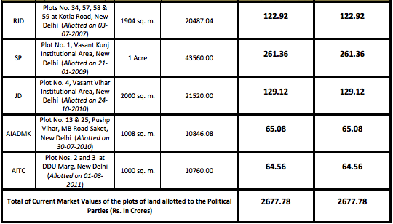

- The government funds political parties by providing them free airtime on Doordarshan during election campaign worth crores of rupees.

Buy rate for air time on Doordarshan during prime time is Rs. 60,000 per ten-second while for Mid- prime, and Non- prime it is Rs. 15,000 per ten seconds. Below is the detail of the government funding to national political parties by the way of free air time during the 2009 Lok Sabha elections.
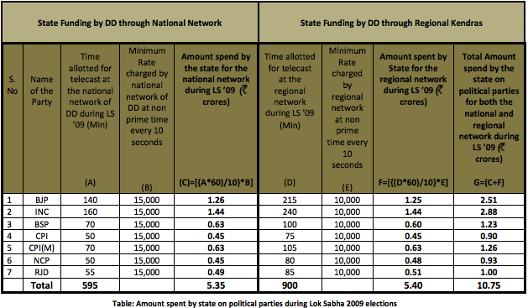

It can be seen that the Central government spent Rs 10.75 Crore only on seven political parties and many regional parties are making the amount much more than this.

- The government funds political parties by providing them free airtime on AIR during elections.

Buy rate for airtime on All India Radio is Rs. 1,200 for 10 seconds between 7 PM to 10 PM. It is for Rs. 1,000 for 10 seconds between 10 PM to 1 AM while between 1 AM to 6 AM, it is Rs. 800 per 10 seconds. Below is the data of government funding by the means of airtime on All India Radio during the 2009 general elections,
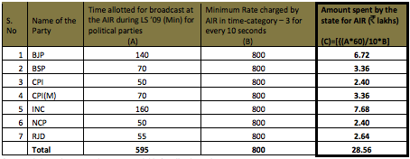

- Government funding in the form of providing electoral rolls during the elections is another type of funding that the government does to substantially finance the government. The government spent Rs 9.15 crore for providing electoral rolls to parties in the Lok Sabha election 2009. Further, refer data:

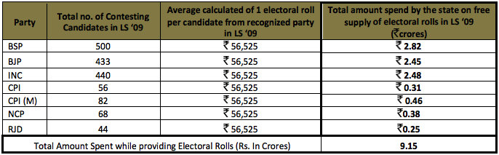

- Government funding in the form of heavy tax exemption to the political parties under Section 13 A of Income Tax Act.
The table below shows the income tax payable by the parties in five years from which they are exempted.
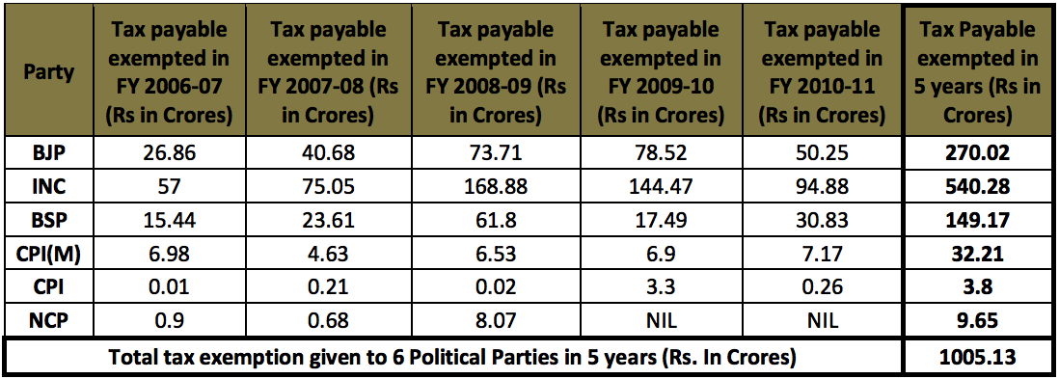

If after getting a tax exemption of roughly 200 crores per year, the parties are saying that they are not the public authority then it’s quite ironic. After going through the above data it is clear that political parties are heavily financed by the state.

In Bangalore International Airport Limited v. Karnataka Information Commission, it was held that the facilities which can lead to cash translation and not only direct financing would amount to substantial financing. For e.g.- grants, subsidies, concessions and agricultural plots.

ARGUMENTS FROM BOTH SIDES

On one side, citizens and social activists are holding demand to make the functioning of political parties transparent and accountable to the public. Keeping in view the democratic set up of a country, transparency, and accountability of public authority is a pillar to the whole institution (Also refer to three arguments given by CIC, which is mentioned above).Exempted circumstances are mentioned in Section 8 & 9 of the RTI Act which states about when the required information can be denied. There is no mention of political parties in the list. This indicates that there is a clear intention to contain political parties under the domain of Act. Hence, it can be interpreted that political parties fall under the extended meaning of ‘public authority’. The nature of duties performed by political parties and the critical role played by them in our democratic setup points towards their public character. They act as life and blood of India’s polity. As political parties have their control over almost every state’s organ, it would not be right to argue that it is good to have transparency in the state’s organs but not in the political parties.

Public Character

Even after being a non-government institution, these parties tend to exercise important governmental powers. Therefore, public functions are continuously performed by political parties which explain parameters of socio-economic development and governance in the country. Also, political parties are recognized by the constitution and Parliament has made laws and Act to govern its members too such as provisions for empowering the parties to issue whips which make it binding for members to vote as per the party’s decision and Anti defection law are provided under the 10th Schedule of The Indian Constitution. As per the Law Commission’s 170th report on electoral law reform, it states that if the core of the country’s constitutional system is constituted by accountability and democracy then the same must be binding for the political parties as they are the integral part of democracy. It is required by the political parties to report all the donations received by them from every source. The provisions for the same are mentioned under the Representation of the People Act’s Section 29C. The obligation under this act directs toward the public character of the political parties. It can be derived that political parties are public authorities by reading Representation of People Act’s Section 29A, 29B, and 29C along with the 10th schedule of the Indian Constitution. Election commission allots a unique symbol to parties for contesting elections and can also withdraw the same from parties if they are found violating the model code of conduct. This clearly indicates their public character.
Not including political parties under the ambit of RTI is creating a class within a class and is a clear violation of Article 14. Also, excluding them is an arbitrary classification and is totally against constitutional values.
On the other side, members of almost all political parties deny the categorization of their parties under the head of the public authority. They consider political parties as a private organization and nor governmental. Such inclusion hinders or obstructs the internal functioning and reduces their efficiency. In section 4 (1)(b) of the RTI Act, it is recommended to disclose such information, in which the public is highly interested, on their official website. This would inevitably reduce the number of RTI applications concerning the same information. Such voluntary disclosure is called for. To ensure the legitimacy of the sources, the comprehensive data will be disclosed. The fear of misuse of information by a rival party is also prevalent. Moreover, important information required by the public is available at websites such as of Election Commission and they see no point in disclosing it again.

WHAT’S NEXT?

In Case, Common Cause V/s UOI and others the SC stated that political parties are not at all accountable to anyone, there is no system of proper audit and accounts. Non-disclosure of spending shows that there prevails free flow of black money in the electoral process by doing a violation of the mandatory legal provisions and it can’t be permitted.
The CIC declared that the respondents i.e., the political parties are public authorities. There arises a need to see why institutions are not able to implement the laws and to identify the lacunae and legal gasps in the system. It must be noted that the decision of CIC is binding as given in section 19(7) of the RTI Act. Political parties have neither implemented it nor challenged in any court. In ADR and Subash Chandra Aggarwal v. UOI and Ors., the petitioners wanted the enforcement of the CIC’s order of 2013 but the government filed a counter-affidavit which mentioned the reasons about the non-inclusion of the political parties under the act.
In Namit Sharma vs. UOI, the SC held that “Any order which is passed by the Commission is binding and final can only can be questioned before the Supreme Court or the High Court under Article 226 or Article 32 of the Indian Constitution, respectively. The respondents i.e. the political parties have not questioned the decision of the commission in front of any court therefore the order dated 3.06.2013 is valid, final and binding. Until it is declared by the Supreme Court in its order declaring them public authority, till then political parties can continue having their free reign without being accountable. The ambit of a quasi-judicial body, i.e. The Central Information Commission is highlighted from the above discussion which derives its power from the act.

There is no denying the fact that the decision is based on strong arguments while considering the objectives of the RTI Act. It is a need of the hour to implement the decision taken why CIC back in 2013 to include six national parties, BJP, INC, NCP, CPI(M), CPI and BSP in the ambit RTI Act under the section 2(h).The Election commission must ensure that, in any case of non-compliance by political parties with the RTI Act, Model code of conduct, Income Tax Act and RPA’s provisions and other election-related laws, their recognition should be taken away and they should be left to suffer penalties.

2nd Year Student, RGNUL(Punjab)
2nd Year Student, SLS(Noida)
Right to Information Act, 2005, Preamble, Acts of Parliament, 2005(India).
Bringing Information to the Citizens, RTI Portal, https://rti.gov.in/aboutrti.asp.
Klaus Schawb, The Global Competitiveness Report 2019, WORLD ECONOMIC FORUM, (Oct. 08, 2019),http://www3.weforum.org/docs/WEF_TheGlobalCompetitivenessReport2019.pdf.
Nidhi Sharma, 1.75 crore RTI applications filed since 2005: Study, THE ECONOMIC TIMES, (Oct. 06, 2016).
Supra
1975 AIR 865, 1975 SCR (3) 333.
1989 AIR 190, 1988 SCR Supl. (3) 212.
Roshni Sinha, Explainer: The Right to Information (Amendment) Bill, 2019, PRS INDIA (Jul. 19,2019), https://prsindia.org/theprsblog/explainer-right-information-amendment-bill-2019.
Bringing Information to the Citizens, RTI PORTAL,(2015), https://rti.gov.in/aboutrti.asp.
Supra
Shoumojit Banerjee, Centre’s decision to bring amendments to RTI Act draws criticism from activists, THE HINDU, (Jul. 22, 2019),https://www.thehindu.com/news/states/centres-decision-to-bring-amendments-to-rti-act-draws-criticism-from-activists/article28629973.ece.
RTI Act and Political Parties in India, JVS, April 8, 2019, https://www.jatinverma.org/rti-act-vis-a-vis-political-parties-in-india.
List of Political Parties & Symbol MAIN Notification dated 15.03.2019, ELECTION COMMISSION OF INDIA, (Mar. 15, 2019), https://eci.gov.in/files/file/9438-list-of-political-parties-symbol-main-notification-dated-15032019/.
Analysis of Sources of Funding of National and Regional Parties- FY 2004-05 to 2014-15, ASSOCIATION FOR DEMOCRATIC REFORMS, (Jan. 24, 2017), https://adrindia.org/content/analysis-sources-funding-national-and-regional-parties-fy-2004-05-2014-15-0.
Niranjan Sahoo &amp; Niraj Tiwari, Financing elections in India: A scrutiny of corporate donation, OBSERVER RESEARCH FOUNDATION, (Apr. 09, 2019),https://www.orfonline.org/expert-speak/financing-elections-india-scrutiny-corporate-donation-49750/.
Analysis of Sources of Funding of National Parties of India, FY 2017-18, ASSOCIATION FOR DEMOCRATIC REFORMS, (Jan. 23, 2019), https://adrindia.org/content/analysis-sources-funding-national-parties-india-fy-2017-18.
The Representation of the People Act, 1951, Section 29C, Acts of Parliament, 1951 (India).
Analysis of Sources of Funding of National Parties of India, FY 2017-18, ASSOCIATION FOR DEMOCRATIC REFORMS, (Jan. 23,2019),https://adrindia.org/content/analysis-sources-fundingnational-parties-india-fy-2017-18.
Bhartiya Janata Party Annual Audit Report Annual Audit Report 2017-18, ELECTION COMMISSION OF INDIA, (Nov. 28, 2018), https://eci.gov.in/files/file/9135-bhartiya-janata-party-annual-audit-reportannual-audit-report-2017-18/.
Shoaib Daniyal, In charts: Who funds India’s political parties?, SCROLL.IN (Feb. 05, 2019, 07:00 AM), https://scroll.in/article/911190/in-charts-anonymous-funding-dominates-indian-politics-and-electoralbonds-have-made-it-worse.
Foreign funding of political parties after 1976 exempted from scrutiny, THE HINDU, (Mar. 15, 2018), https://www.thehindubusinessline.com/news/national/foreign-funding-of-political-parties-after-1976-exempted-from-scrutiny/article23263844.ece.
Mohammed Kudrati, Foreign Funding For Political Parties: All You Need To Know, BOOM, (Mar. 25, 2019, 01:53 PM),https://www.boomlive.in/foreign-funding-for-political-parties-all-you-need-too-know/.
Association for Democratic Reforms v Union of India &Ors. [2014] WP(C) 131/2013.
Finance Bill, 2018, CENTRAL BOARD OF INDIRECT TAXES AND CUSTOMS (Apr. 01, 2018), http://www.cbic.gov.in/resources/htdocs-cbec/ub1819/finbill2018.pdf.
Kaushik Deka, Political funding: Who pays for the party?, INDIA TODAY (Nov, 19, 2018), https://www.indiatoday.in/magazine/the-big-story/story/20181119-political-funding-who-pays-for-theparty-1384158-2018-11-09.
Tom Carver &amp; Milan Vaishnav, Milan Vaishnav on Corruption in Indian Politics, CARNEGIE ENDOWMENT FOR INTERNATIONAL PEACE, (Feb. 02,2017),https://carnegieendowment.org/2017/02/02/milan-vaishnav-on-corruption-in-indian-politics-pub-67883.
John Hudson, The Most Expensive Election in History by the Numbers, THE ATLANTIC (Nov. 06, 2013), https://www.theatlantic.com/politics/archive/2012/11/most-expensive-election-history-numbers/321728/
Lindsay Ferris, How dominant parties stay dominant in Uruguay, SUNLIGHT FOUNDATION (Nov. 04,2016), https://sunlightfoundation.com/2014/11/04/how-dominant-parties-stay-dominant-in-uruguay/.
Magnus Ohman, Political Finance Regulations Around the World, THE INTERNATIONAL IDEA, (Jun. 01, 2012), https://www.idea.int/sites/default/files/publications/political-finance-regulations-around-the-world.pdf.
Public Financing of Election Campaigns, THE CAMPAIGN LEGAL CENTRE, https://campaignlegal.org/sites/default/files/Public Financing Fact Sheet.pdf.
Party research program, UNIVERSITY OF GOTHENBURG, (Dec. 16, 2016), https://partiforskning.gu.se/english/partyfinancing.
Political parties to come under RTI - landmark judgment by CIC, ASSOCIATION FOR DEMOCRATIC REFORMS, (Jun. 02, 2013), https://adrindia.org/content/political-parties-come-under-rti-landmark-judgement-cic.
AIR 190 (SC 1989).
CIC's Nudge: Transparency and accountability of political parties will only strengthen democracy, Vol No. 48, ECONOMIC AND POLITICAL WEEKLY, Pg-7, Pg-7(2013).
Nidhi Sharma, CIC divided over bringing political parties under RTI, THE ECONOMIC TIMES, (Aug. 20, 2018, 11:25PM), https://economictimes.indiatimes.com/news/politics-and-nation/cic-divided-over-bringing-political-parties-under-rti/articleshow/65479368.cms?from=mdr-
Japnam Kaur Bindra, SC notice to center, EC to bring parties under RTI, LIVEMINT, (Apr. 15, 2019, 11:54 PM), https://www.livemint.com/politics/policy/sc-notice-to-centre-ec-to-bring-parties-under-rti-1555352461517.html.
Right to Information Act, 2005, Section 2(h), Acts of Parliament, 2005(India).
Mr.Subhash Chandra Agrawal vs Parliament Of India CIC/SM/C/2011/001386 (India).
Supra.
Supra
Supra
Supra
Supra
Supra
ILR 3214 (Kar 2010).
Political Parties under RTI, ADR, July 11, 2013, https://adrindia.org/content/political-parties-under-rti.
RTI Act and Political Parties in India, JVS, April 8, 2019, https://www.jatinverma.org/rti-act-vis-a-vis-political-parties-in-india.
170th Report of Law Commission of India on Reform of the Electoral Laws, LAW COMMISSION OF INDIA, (1999), http://www.lawcommissionofindia.nic.in/lc170.htm.
Common Cause v. UOI. and Ors (1996) [(1996)2 SCC 752] (India).
Namit Sharma v. Union of India, (2012) 1 S.C.C WRIT PETITION (CIVIL) NO. 210 of 2012 (India).
Press Trust of India, Plea in SC for bringing political parties in RTI , DECCAN HERALD, (April 7, 2019), https://www.deccanherald.com/national/north-and-central/plea-in-sc-for-bringing-political-parties-under-rti-727342.html.

